# **Guide To Excellent Soldering**

By [Bill Earl](https://learn.adafruit.com/users/adafruit_support_bill) Upgraded by GranaSAT Group V0.1

## Tools

[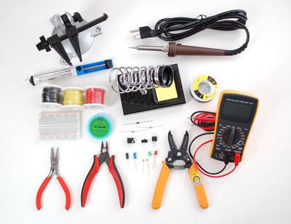](https://learn.adafruit.com/assets/2027)

# **Building a Soldering Toolkit**

If you are just getting started in Electronics, [Ladyada's Electronics Toolkit](http://www.adafruit.com/products/136) (pictured above) is a great kit full of quality tools - including everything you need to make great solder joints.  If you would rather build your toolkit piece-by-piece, read on:

# **Choosing a Soldering Iron**

There are many types of soldering irons.  For most Adafruit kits and projects, you will want a pencil-style soldering iron with 25 watts or more.    
  
An under-powered iron is a poor investment.  It will end up costing you more in ruined kits and damaged components.

* It will take longer to heat the joint, allowing heat to spread to the component being soldered - potentially overheating and damaging the component.
* Longer heating times will also give more time for oxides to form on the surfaces being soldered.  This will prevent the solder from flowing and result in a poor joint.
* Longer recovery times between joints can result in frustration, 'cold joints' or both.

You don't need to spend a fortune to get a good iron.  Advanced features such as temperature control and interchangeable tips are nice to have, but not essential for hobbiest-level work.

|  |  |
| --- | --- |
| * [tools_2012_09_03_IMG_0627-1024.jpg](https://learn.adafruit.com/assets/1981) | Basic Irons There are many basic pencil style irons that are suitable for hobbiest use.  But you will need one that is capable of heating the joints quickly enough.  Choose an iron with 25 watts at a minimum. |
| * [tools_xytronics258usa_LRG.jpg](https://learn.adafruit.com/assets/1982) | Better Irons An adjustable temperature iron with a little more power will give you a bit more control and allow you to work faster.  The [Adjustable 30W 110v Soldering Iron](http://www.adafruit.com/products/180) in the store is an excellent choice.  This iron is also available as part of [Ladyada's Electronics Toolkit](https://www.adafruit.com/products/136), which contains many other essential soldering tools. |
| * [tools_Hakko_Fx88.jpg](https://learn.adafruit.com/assets/1983) | Best Irons A professional-style temperature-controlled iron with interchangeable tips and 50 watts or more of power is a joy to work with.  Feedback control keeps the tip temperature at precisely the level you set.  The extra watts speed recovery time so that you can work faster. Interchangeable tips let you select the ideal tip shape for specialized work.  The 65 watt [Hakko FX-888](http://www.adafruit.com/products/303) is an excellent professional quality soldering iron.  The Weller WES51 or WESD51 are also excellent choices for serious electronics work. |

# **Irons to avoid**

In addition to underpowered irons, there are several types of irons to avoid for general circuit-board work.

|  |  |
| --- | --- |
| * [tools_2012_09_03_IMG_0628-1024.jpg](https://learn.adafruit.com/assets/1986) | For emergencies only: These irons are handy for occasions when you have no place to plug in a regular soldering iron. But they are not the best choice for a primary soldering tool:   * **Butane Powered Irons** have plenty of power but are difficult to control. * **Battery Powered Irons** are generally underpowered for most work. |
| * [tools_2012_09_03_IMG_0626-1024.jpg](https://learn.adafruit.com/assets/1987) | Not for circuit board use: These tools are not suitable for circuit board work:   * **Torches**of any kind are not suitable for electronics work and will damage your circuit boards. * **Soldering Guns** are OK for working with heavy gauge wires, but don't have the precision necessary for soldering delicate electronics components. * **Cold-Heat™**Irons inject current into the joint to heat the tip.  This current can be damaging to sensitive electonic components.  Avoid these irons for electronics work. |

# **Essential Tools and Supplies:**

These tools are the bare-minimum essentials required for soldering:

|  |  |
| --- | --- |
| * [tools_ironholder_MED.jpg](https://learn.adafruit.com/assets/2020) | Stand If your soldering iron does not have a built-in stand, you will need a safe place to rest the hot iron between uses.  A [Soldering Iron Stand](http://www.adafruit.com/products/150) will keep your iron from rolling around and protect both you and your work surface from burns.  Most stand holders come with a sponge and tray for cleaning your soldering iron. |
| * [tools_Solder.jpg](https://learn.adafruit.com/assets/2021) | Solder Standard [60/40 lead/tin Rosin Core Solder](http://www.adafruit.com/products/145) is the easiest type to work with. |
| * [tools_Cutters.jpg](https://learn.adafruit.com/assets/2022) | Diagonal Cutters You will also need a pair of [Diagonal Cutters](http://www.adafruit.com/products/152) for trimming component leads after soldering. |

# **Other Handy Tools and Supplies**

These are some other tools and supplies you might find useful when working on soldering projects.

|  |  |
| --- | --- |
| * [tools_2012_09_03_IMG_0621-1024.jpg](https://learn.adafruit.com/assets/2023) | Vise A vise holds your work steady as you solder.  This is important for both safety and sound joints.  The[Panavise Jr](http://www.adafruit.com/products/151) is an ideal size for most Adafruit kits and projects. |
| * [tools_thirdhand_MED.jpg](https://learn.adafruit.com/assets/2024) | Third Hand A [Helping Third Hand](http://www.adafruit.com/products/291) Tool is good for smaller boards, or to hold things in place while terminating or splicing wires. |
| * [tools_soldersucker_MED.jpg](https://learn.adafruit.com/assets/2025) | Solder Sucker A [Solder Sucker](https://www.adafruit.com/products/148) is a very helpful tools for removing excess solder or when you need to de-solder a joint.  As the name implies, this device literally sucks the solder out of the joint. |
| * [tools_wick_MED.jpg](https://learn.adafruit.com/assets/2026) | Solder Wick [Solder Wick](https://www.adafruit.com/products/149) is another way to clean excess solder from a joint.  Unlike the solder sucker, the wick soaks up the molten solder. |

## Preparation

|  |  |
| --- | --- |
| [tools_2012_09_03_IMG_0625-1024.jpg](https://learn.adafruit.com/assets/1979) | Heat the Iron Plug an and/or turn on your soldering iron to warm up.  If you are using a temperature controlled iron, set it to 700F/370C for 60/40 or 750F/400C for lead-free solder.  While the iron is heating dampen the sponge with a little bit of water. |
| [tools_Sponge.jpg](https://learn.adafruit.com/assets/1962) | Clean the Iron Wipe the tip of the hot iron on the damp sponge to clean off any oxidation.  Do not use files or abrasives to clean the tip.  It will damage the plating and ruin the tip. |
| [tools_Tinned.jpg](https://learn.adafruit.com/assets/1963) | Tin the Tip Apply a small amount of solder to the tip and wipe again to tin the tip.  You should have a thin, shiny layer of molten solder on the tip of your iron.  If the tip is badly oxidized and difficult to tin, it can usually be reconditioned with some tip-tinning paste. |
| [tools_Cleaning.jpg](https://learn.adafruit.com/assets/1965) | Make sure that the joint is clean Dirt, oxidation and oily fingerprints can prevent the solder from wetting the solder-pad to create a solid joint.  All Adafruit boards are plated to prevent oxidation, but if your board appears dirty from storage or handling, wipe it down with a little isopropyl alcohol. |
| [tools_Immobilize.jpg](https://learn.adafruit.com/assets/1967) | Immobilize the Joint This is very important!  The parts being joined must not move during the soldering process.  If there is any movement as the molten solder is solidifying, you will end up with an unreliable 'cold joint'.  Most through-hole components can be immobilized by simply bending the leads on the solder-side of the hole. |
| [tools_2012_09_03_IMG_0621-1024.jpg](https://learn.adafruit.com/assets/1980) | Steady the Board A vise is a good way to keep the board from moving around while you try to solder it.  Once the joint is clean and immobilized, you are ready to apply |

## Making a good solder joint

[Save](https://learn.adafruit.com/guides/102/favorites.js) [Subscribe](https://learn.adafruit.com/adafruit-guide-excellent-soldering/making-a-good-solder-joint)

[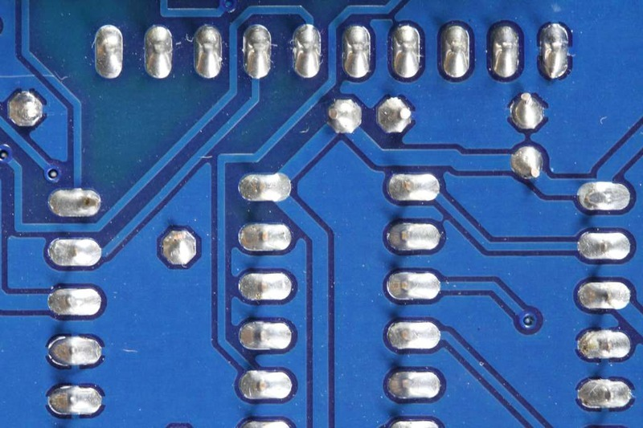](https://learn.adafruit.com/assets/2017)

Once you have prepared the your tools and the joint to be soldered, making a good solder joint requires just a few simple steps.

|  |  |
| --- | --- |
| [tools_Heating.jpg](https://learn.adafruit.com/assets/1968) | Heat the joint Heat the joint with the tip of the iron.  Be sure to heat both the solder pad and the component lead or pin.  A small drop of solder on the tip will help to transfer the heat to the joint quickly. |
| [tools_Apply_Solder.jpg](https://learn.adafruit.com/assets/1996) | Apply the solder Touch the end of the solder to the joint so that it contacts both the solder pad and the component lead or pin.  It should melt and flow smoothly onto both the pin and the pad.   If the solder does not flow, heat the joint for another second or two and try again. |
| [tools_flow.jpg](https://learn.adafruit.com/assets/1999) | Let It Flow Keep heating the solder and allow it to flow into the joint. It should fill the hole and flow smoothly onto both the solder pad and the pin or component lead. Let It Cool Once enough solder has been added to the joint and it has flowed well onto both the component lead and the solder pad, remove the iron from the joint and allow it to cool undisturbed. |
| [tools_Trim.jpg](https://learn.adafruit.com/assets/2002) | Trim the Lead Use your diagonal cutters to trim the lead close to the board.  *Note: This step applies only to components with wire leads.  It is not necessary to trim the pins on Integrated circuit chips or sockets.* |

[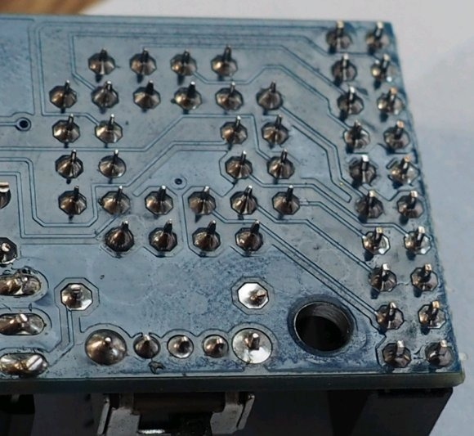](https://learn.adafruit.com/assets/17179)

|  |  |
| --- | --- |
|  |  |

## Surface Mount Components

[Save](https://learn.adafruit.com/guides/102/favorites.js) [Subscribe](https://learn.adafruit.com/adafruit-guide-excellent-soldering/surface-mount)

The previous page showed how to make a good through-hole joint.  But more and more components are only available in surface mount form these days.  Not all surface mount packages are easily worked by hand, but there are plenty that can be managed with the same basic tools used for through-hole soldering.  
  
Let's start with a surface-mount part common to several Adafruit kits: The SD Card Holder:

|  |  |
| --- | --- |
| * [tools_Surface_Mount_Immobilize.jpg](https://learn.adafruit.com/assets/2046) | Immobilize the Joint Unlike many surface mount components, immobilizing the SD card holder is relatively easy.  There are small pegs on the back that fit into positioning holes in the board.  Once it is in place, solder the four small corner tabs to make it permanent. |
| * [tools_Surface_Mount_Heat.jpg](https://learn.adafruit.com/assets/2041) | Heat the Joint Start by putting the tip of the hot iron on the solder pad adjacent to the pin.  The pad will take longer to heat, so we apply most of the heat to the pad to start. |
| * [tools_Surface_Mount_Solder.jpg](https://learn.adafruit.com/assets/2042) | Apply the Solder When the joint is hot, apply solder to the side opposite the iron.  The solder should melt and start to flow into the joint. |
| * [tools_Surface_Mount_Wick.jpg](https://learn.adafruit.com/assets/2043) | Let it Flow Apply just enough solder to ensure a good joint, then keep the heat on while the solder wicks up between the pin and the pad to make a good electrical bond. |
| * [tools_Surface_Mount_Cool.jpg](https://learn.adafruit.com/assets/2044) | Let it Cool Remove the iron and allow the joint to cool undisturbed. |

## Problems?

The last page of this guide illustrates a number of common soldering problems with advice on prevention and repair.

Common Soldering Problems

[Save](https://learn.adafruit.com/guides/102/favorites.js) [Subscribe](https://learn.adafruit.com/adafruit-guide-excellent-soldering/common-problems)

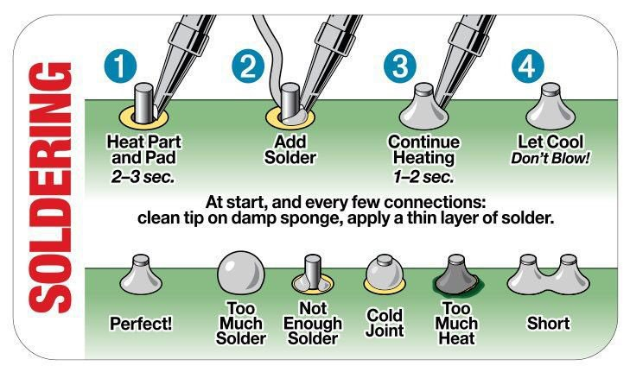[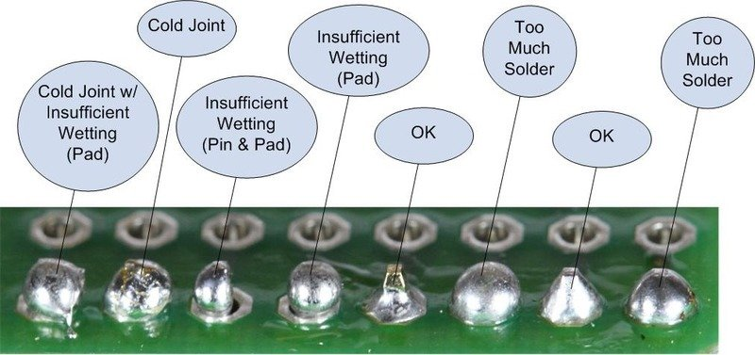](https://learn.adafruit.com/assets/1978)

The Ideal Solder Joint

The ideal solder joint for through-hole components should resemble the diagram below.

[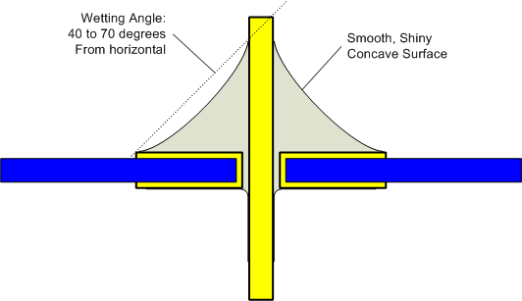](https://learn.adafruit.com/assets/2029)

The photos that follow show some common soldering problems, with suggestions for repair and prevention:

|  |  |
| --- | --- |
| * [tools_2012_09_05_IMG_0647-1024.jpg](https://learn.adafruit.com/assets/2010) | Disturbed Joint  A Disturbed joint is one that has been subjected to movement as the solder was solidifying.  The surface of the joint may appear frosted, crystalline or rough.  Often called a 'Cold Joint'.  They can look similar to a true cold joint, but the cause is different.  **Repair:** This joint can be repaired by reheating and allowing it to cool undisturbed.  **Prevention:**  Proper preparation, including immobilizing the joint and stabilizing the work in a vise can prevent disturbed joints. |
| [tools_Cold.jpg](https://learn.adafruit.com/assets/1972)  [tools_Cold.jpg](https://learn.adafruit.com/assets/1972)[tools_Pot.png](https://learn.adafruit.com/assets/11261)  [tools_Cold.jpg](https://learn.adafruit.com/assets/11262)[tools_cobbler_front.jpg](https://learn.adafruit.com/assets/11264) | Cold Joint  A 'Cold Joint' is one where the solder did not melt completely. It is often characterized by a rough or lumpy surface. Cold joints are unreliable. The solder bond will be poor and the cracks may develop in the joint over time.  **Repair:**Cold joints can usually be repaired by simply re-heating the joint with a hot iron until the solder flows. Many cold joints (such as the one pictured) also suffer from too much solder. The excess solder can usually be drawn-off with the tip of the iron. **Prevention:** A properly pre-heated soldering iron with sufficient power will help prevent cold joints. |
| [tools_Overheated.jpg](https://learn.adafruit.com/assets/1973)  [tools_Overheated.jpg](https://learn.adafruit.com/assets/1973)[tools_cobbler_back.jpg](https://learn.adafruit.com/assets/11265)  [tools_IBM.jpg](https://learn.adafruit.com/assets/11266) | Overheated Joint  At the other extreme, we have the overheated joint. The solder has not yet flowed well and the residue of burnt flux will make fixing this joint difficult.  **Repair**: An overheated joint can usually be repaired after cleaning. Careful scraping with the tip of a knife, or little isopropyl alcohol & a toothbrush will remove the burnt flux.  **Prevention:** A clean, hot soldering iron, proper preparation and cleaning of the joint will help prevent overheated joints. |
| [tools_Pad_Wetting.jpg](https://learn.adafruit.com/assets/1974)  [tools_Pad_Wetting.jpg](https://learn.adafruit.com/assets/1974)[tools_wavefront.jpg](https://learn.adafruit.com/assets/11256)  [tools_waveback.jpg](https://learn.adafruit.com/assets/11258)[tools_badstuff.png](https://learn.adafruit.com/assets/11259)  [tools_photo_2.jpg](https://learn.adafruit.com/assets/11260) | Insufficient Wetting (Pad)  These two joints both show signs of insufficient wetting of the solder pad. The solder has wetted the leads nicely, but it has not formed a good bond with the pad. This can be caused by a dirty circuit board, or by failing to apply heat to the pad as well as the pin.  **Repair:** This condition can usually be repaired by placing the tip of the hot iron at the base of the joint until the solder flows to cover the pad.  **Prevention:** Cleaning the board and even heating of both the pad and the pin will prevent this problem. |
| [tools_Wetting.jpg](https://learn.adafruit.com/assets/1975)  [tools_Wetting.jpg](https://learn.adafruit.com/assets/1975)[tools_badstuff.png](https://learn.adafruit.com/assets/11249) | Insufficient Wetting (Pin)  This solder in this joint has not wetted the pin at all and has only partially wetted the pad. In this case, heat was not applied to the pin and the solder was not given adequate time to flow.  **Repair**: This joint can be repaired by re-heating and applying more solder. Be sure that the tip of the hot iron is touching both the pin and the pad.  **Prevention**: Even heating of both the pin and the pad will prevent this problem. |
| [tools_surface_mount_no_wetting.jpg](https://learn.adafruit.com/assets/2047)  [tools_surface_mount_no_wetting.jpg](https://learn.adafruit.com/assets/2047)[tools_surfaceMountx.jpg](https://learn.adafruit.com/assets/11251) | Insufficient Wetting  (Surface Mount)  Here we have three pins of a surface mount component where the solder has not flowed onto the solder pad. This is caused by heating the pin instead of the pad.  **Repair:** This is easily repaired by heating the solder pad with the tip of the iron, then applying solder until it flows and melts together with the solder already on the pin.  **Prevention:** Heat the pad first. |
| [tools_Solder_starved.jpg](https://learn.adafruit.com/assets/2011)  [tools_Solder_starved.jpg](https://learn.adafruit.com/assets/2011)[tools_cobbler_back.jpg](https://learn.adafruit.com/assets/11252) | Solder Starved  A solder starved joint simply does not have enough solder. It may make good electrical contact, but it is hard to verify by inspection. In any case, it is not a strong joint and may develop stress cracks and fail over time.  **Repair:** Re-heat the joint and add more solder to make a good strong joint. |
| [tools_Too_Much.jpg](https://learn.adafruit.com/assets/2014)  [tools_Too_Much.jpg](https://learn.adafruit.com/assets/2014) [tools_Photo_on_9-14-13_at_12.24_AM.jpg](https://learn.adafruit.com/assets/11255) | Too Much Solder  This might be a perfectly good joint, but we can't tell for sure. It is entirely possible that this blob of solder wets neither the pin nor the pad and is not a reliable electrical connection. The best evidence of proper wetting (and good electrical contact) is a nice concave surface as on the joint on the far left.  **Repair:** It is usually possible to draw off some of the excess solder with the tip of a hot iron. In extreme cases, a solder-sucker or some solder wick can be helpful as well. |
| * [tools_Too_Long.jpg](https://learn.adafruit.com/assets/2015)   [tools_Too_Long.jpg](https://learn.adafruit.com/assets/2015)[tools_back2.jpg](https://learn.adafruit.com/assets/11263)  [tools_IceTube.jpg](https://learn.adafruit.com/assets/11267) | Untrimmed Leads  Leads that are too long are potential short circuits. The two joints on the left are an obvious danger of touching. But the one on the right is long enough to be dangerous as well. It would not take much force to bend that lead over to touch an adjacent trace.  **Repair**: Trim all leads just at the top of the solder joint. |
| [tools_Solder_Bridge.jpg](https://learn.adafruit.com/assets/2048)  [tools_Solder_Bridge.jpg](https://learn.adafruit.com/assets/2048)[tools_Ring.jpg](https://learn.adafruit.com/assets/11244)  [tools_Photo_on_9-14-13_at_12.24_AM.jpg](https://learn.adafruit.com/assets/11245)[tools_Photo_on_9-14-13_at_12.25_AM.jpg](https://learn.adafruit.com/assets/11246)[tools_bridge.jpg](https://learn.adafruit.com/assets/11254) | Solder Bridge  The left two solder joints have melted together, forming an unintended connection between the two.  **Repair:**Sometimes the excess solder can be drawn off by dragging the tip of a hot iron between the two solder joints. If there is too much solder, a solder sucker or solder wick can help get rid of the excess.  **Prevention:** Solder bridges most often happen between joints with too much solder to begin with. Use only enough solder to make a good joint. |
| * [tools_Lifted_Pad.jpg](https://learn.adafruit.com/assets/2039) | Lifted Pad  This photo shows a solder pad that has become detached from the surface of the circuit board. This most often occurs when trying to de-solder components from the board. But it can result simply from overworking the joint to the point where the adhesive bond between copper and the board is destroyed.  Lifted pads are especially common on boards with thin copper layers and/or no through-plating on the holes. |
| * [tools_Lifted_Pad_Repair.jpg](https://learn.adafruit.com/assets/2040) | Repairing a Lifted Pad  It may not be pretty, but a lifted pad can usually be repaired.  The simplest repair is to fold the lead over  to a still-attached copper trace and solder it as shown to the left.  If your board has a solder-mask, you will need to carefully scrape off enough to expose the bare copper.  Other alternatives are to follow the trace to the next via and run a jumper to there.  Or, in the worst case, follow the trace to the nearest component and solder your jumper to the leg of that.  Not exactly pretty, but functional. |
| [tools_Spatters.jpg](https://learn.adafruit.com/assets/11358)   * [tools_Spatters.jpg](https://learn.adafruit.com/assets/2049)[tools_Spatter.jpg](https://learn.adafruit.com/assets/11358) | Stray Solder Spatters  These bits of solder are held to the board only by sticky flux residue. If they work loose, they can easily cause a short circuit on the board.  **Repair:** These are easy to remove with the tip of a knife or tweezers. |
| * [tools_IBM.jpg](https://learn.adafruit.com/assets/2030) | All of the Above!  Don't panic. Take your time.  Most joints can be repaired with patience.  If the solder refuses to flow the way you want it to:   1. Stop and let the joint cool. 2. Clean and tin your iron. 3. Clean off any burnt flux from the joint. 4. Let the iron come back up to temperature. 5. Then reheat the joint and try again. |